# Design and Development of Coloring Game based on Augmented Reality Technology by a case study

The development of technology from Virtual Reality (VR) to Augmented Reality (AR) makes the combination of the real world and the virtual world a reality, which makes the Chinese story "Legend Painter Ma Liang" [1] no longer a legend. The AR technology has been increasingly used in various fields of the society, changing people’s way of life. Coloring games developed on the basis of the AR technology have brought a market potential in Early childhood education. Based on the analyses of the characteristics of the AR technology and its use in education, this paper took the 3D interactive mobile application named “Color the Earth” as an example to elaborate on the AR Coloring games regarding their characteristics, product design, and technology realization etc. and Designed and developed a Coloring game named “Coloring XiXi”. It is hoped that the results of the study may offer some references for the research on and the application of the AR Coloring games.

Keyword: Augmented Reality; AR Educational application; Mobile game

# Introduction

With the popularization of the Internet, the globalization of information is undeniable. The continuous development of science has driven the revolution of technology. The idea of combining the virtual situation with reality has aroused people's attention. As early as the 1960s, the United States began to study augmented reality technologies. With the continuous upsurge of foreign research climaxes, augmented reality technologies have begun to be recognized by more and more people and gradually gained attention. It can be seen that augmented reality technology will play an important role in the future education. Augmented reality technology is becoming a hot spot in teaching and research in education field.

* 1. The Augmented Reality technology
     1. Concept of Augmented Reality

Augmented Reality, AR for short, is a new technology that has emerged with the development of virtual reality technology in recent years. It involves many fields such as computer graphics, human-computer interaction technology, pattern recognition, and computer vision. Many experts and scholars study augmented reality technologies and define them under specific research categories. Professor Ronald Azuma [3] at the University of North Carolina University summarized the augmented reality into three parts: virtual-reality integration, real-time interaction and three-dimensional registration.

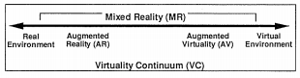

Fig.1 Simplified representation of a “virtuality continuum.”

Paul Milgram and Fumio Kishino proposed the “Virtuality continuum”, the Reality and the virtual environment as the two ends of the continuum, and the middle of them is called the "Mixed reality" (Fig. 1). Those which close to the real environment is called Augment Reality (AR) environment, if close to the virtual environment is called Augmented virtual (AV) environment. The above definition refers to the combination of the virtual and the reality. Therefore, the Augmented Reality technology refers to the entity information in the real world which is difficult to experience (visual, auditory, tactile, etc.), through simulation and other technologies to be superimposed on the reality world, so as to be perceived by human beings and achieve an immersive experience beyond the real environment [4]. Simulation technology which uses computer and other professional equipment as basic tools calls the system model which is completed in advance so as to render the object in a virtual form and achieve a high degree of restoration effect. Augmented reality Based on this technology, the virtual object is combined with the real scene so as to achieve the enhancement of the full range of senses such as visual, auditory, tactile, etc. So as to enable the user to immerse and realize the interaction with the reality.

* + 1. Characteristics of AR Technical

Virtual reality provides the user with a completely virtual environment, while Augmented Reality incorporates the virtual environment into the surrounding real-world scene so as to realize the interactive experience with the characteristics of virtual reality and real-time interaction.

1.Combination of virtual and reality

Augmented Reality technology combines virtual with reality so that users can feel directly. Different from the Virtual Reality, Augmented Reality combines the real scene with the virtualized object superimposed on the scene, and achieves the effect of incorporating the virtual stereoscopic graphic in the real scene through a series of technical processes such as optical projection, so as to bring the immersive experience. The combination of the virtual and reality is a core feature of Augmented Reality technology and also a unique feature that can reflect its essence.

2.Interaction

The Augmented Reality technology realizes the human-computer interaction. The people who use this technology can control the appearance of the virtual object on the display device by controlling the buttons in the mobile device scene, and realize the combination of user, devices and interfaces. The user inputs the instruction to the computer, the computer carries out the backstage processing and outputs the result to the user. Through the manipulation the user can also change the interface rendering effect, that emphasize the human-computer interaction in this process.

3. Three-dimensional effect

Augmented reality technology recognizes a specific mark by a specific device or object, and the virtual object receives drawing information to present a three-dimensional object. The pre-existing stereoscopic effect is superimposed on the scene according to the position of the real scene according to different identification marks. This three-dimensional effect make change the abstract plane content to a more intuitively presented in a three-dimensional form, easier and more interesting for the children to see.

* 1. Augmented Reality Technology in Education

At present, Augmented reality technology has begun tentative application in the fields of military affairs, medicine, commerce, education, navigation training and achieved some success. The combination of education and AR technology promotes the deep integration of technology and teaching while creating spatial three-dimensional materials for learners so that they can promote the internalization of knowledge both as teaching contents and as teaching tools, and bring about the innovation and development in the field of education [5]. At present, AR technology in the field of education is mainly reflected in the following aspects:

AR Based Classroom Teaching

K12 "K" on K12 stands for Kindergarten; "12" represents 12 years of elementary and middle school education from the first grade of primary school to the third grade of high school, and K12 is actually The general name of basic education for elementary education. K12 online education institutions are uneven, many platforms do not have high-quality content, students did not learn and grow from their platform. The industry can’t grow without the support of quality and creation content. Augmented Reality education is based on situational learning theory and immersion theory [6]. Emphasize the importance of personal experience. AR-based classroom teaching emphasizes that using AR technology to create a learning situation, the learning resources are superimposed into the real situation for teaching, the use of AR teaching aids change the abstract experience to concrete experience. For example, Prof. Kaufman used the teaching tool named Construct 3D to render complex and abstract spatial geometry into three-dimensional form. He pointed out that the use of AR teaching tools enhances the students' learning efficiency. The improvement of learning effect is also obvious [7]; Cai Su and others provide a typical case based on the AR classroom teaching based on the augmented reality learning environment [8], which provides a model for classroom teaching based on AR. As technology advances, AR technology popularization classroom is at hand.

AR-based skills training

AR-based skills training for college students, especially technology-oriented students to carry out professional practice provides a convenient and intuitive guidance. Engineering students can use AR technology to identify components and simulate the assembly of specialized equipment, the related human teaching AR applications can help to understand the body structure of a person deeply, and promoting such applications in medical training is beneficial to improve the accuracy of cognition. The advent of wearable technologies such as AR helmets and Google glass also provided the material and equipment foundation for skill training.

AR-based Mobile Learning

Use the mobile phone lens to obtain the real information and additional feedback information by the phone superposition on the actual scene to supplement to meet the needs of personalized learning. Mobile learning breaks through space limitations and can be learned anytime, anywhere. Augmented reality technology and the mobile devices combine to present virtual objects in the real world, providing technical support for mobile learning practices and promoting the development of exploratory learning [9].

AR Education Products

AR educational games fully embodies the concept of edutainment, improve the practical ability of students, with the AR research advances and technology development, more and more augmented reality technology based teaching products are designed and developed. Shelton et al. Used AR teaching aids to teach nine planets so that planets in three-dimensional space actually appeared in front of the students, improving teaching interaction and teaching effects [10] shows in Fig.2. Another example is the early education game "Dr. Panda", children can quickly integrate their own role, the establishment of interaction with other animals, explore the world in cooperation and exchange. In addition, the emergence of AR cards and AR 3D e-books has challenged the traditional paper-based books. The AR 3D e-book has utilized the technology of camera calibration and 3D registration to realize the combination of virtuality and reality [11]. Interactive “I Dinosaur” book [12], and the newly developed for children's cognitive literacy named "AR TuTuLe" (Fig 7 (b)).

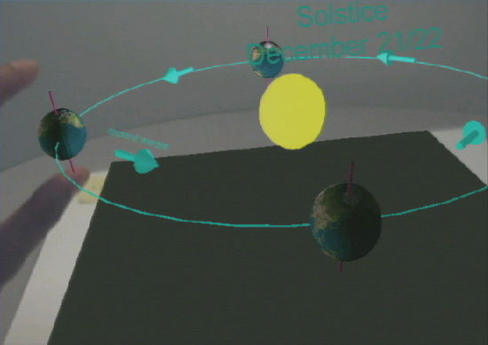

Fig. 2. First person perspective of earth-sun AR exercise.

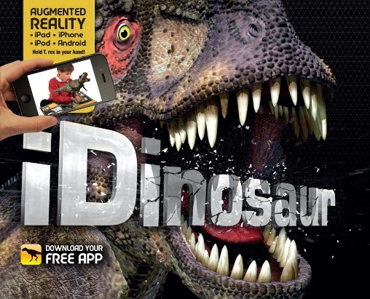

Fig.3. I Dinosaur[20]

# 2. A case study – “Color the Earth AR”

2.1 Coring AR products

AR technology is a combination of virtual image and reality. Interaction should be the main focus of AR. Actually AR technology still stays on the screen of mobile devices due to the absence of smart glasses, resulting in a lot of AR technologies actually are gimmicks, with a receptive visual experience as its mainstay, painted AR products are one of the few successful products in the current AR market that have the following features: high entertainment interactivity; stand alone or as part of a system , Relatively less investment in traditional games; need to collaborate between different areas, mapping UV matching requirements are higher. There are some coloring AR applications shows in follow pics, the main features of colAR Mix is more complex models and animations, and more interactive. Coloring AR two manifestations: 1, real-time rendering model map content; 2, only specify a model map does not render content in real time.

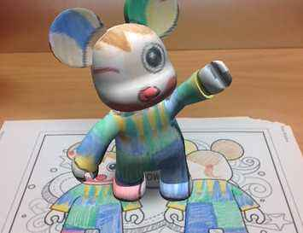 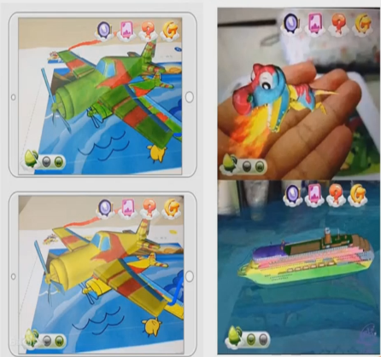

1. (b)

Fig 4 AR ColAR Mix(a); AR TuTuLe(b)

2.2 An Analysis of "Color the Earth AR"

"Color the Earth AR" is a representative augmented reality application where "Color the Earth AR" is analyzed mainly from the characteristics, design, procedures and 3D model design of this application. As shown in Fig.5, align the phone camera with the pictures on the desk, correctly recognize the three-dimensional effect (c) of the objects in the picture on the mobile terminal screen, click the screen to interact with the three-dimensional objects. Once touch the screen, the earth model rotation (a), the second click of the screen, the entire solar system shown as fig(b). The main production process of coloring AR application using Vuforia Target Pics is as follow Fig.6 picture.

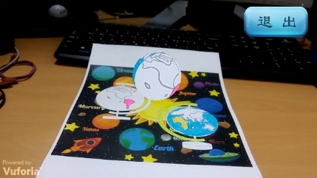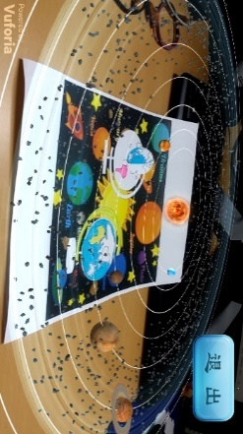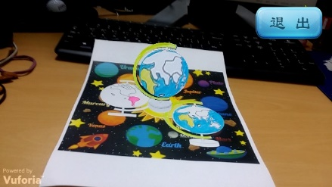

(a) (b) (c)

Fig. 5 game scenes

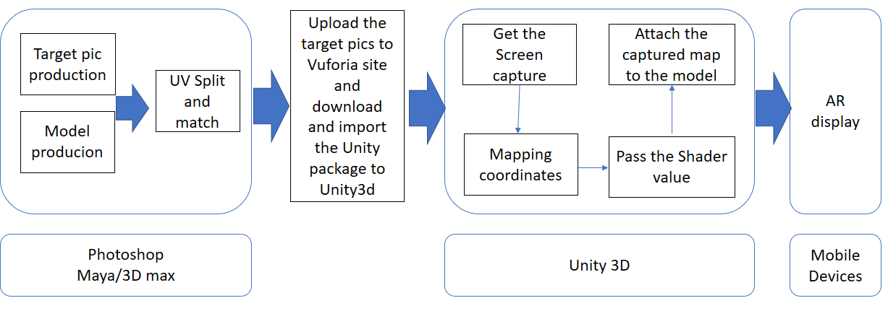

Fig.6. The main production process

1, Target picture and model

Use Photoshop or other applications to make the target pictures, and use maya or other applications to make the model which is corresponding to the target picture. Then upload the target picture to Vuforia site, find the target manager and download the database that we create. Making a Target picture should pay attention to identify the level of the figure, the higher the level, the higher the recognition rate.

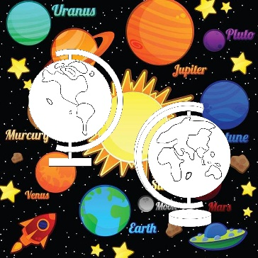

Fig 6. AR target picture

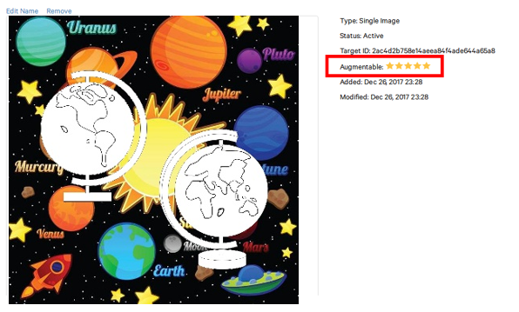 

Fig.7 The augmentable level

2, UV Split and match

UV concept: Two-dimensional texture coordinate points residing on the vertices of a polygon mesh define a two-dimensional texture coordinate system called the UV texture space, which defines the axes with U and V letters. Used to determine how to place a texture image on a three-dimensional model surface. UV is the mapping of the map to the model. For models, UV is not necessary if you do not use textures or 3D textures. UV is only necessary when using 2D textures. In addition to texture, do some special effects animation, it will also use UV.

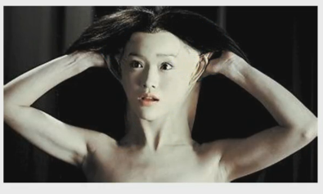

UV- The corresponding relationship between the model and the map.

Expand UV to distinguish UVs from different parts of the model Match UV to model structures on the image Reduce the UV of the less visible part to another part.

3, Vuforia introduction and use of the website

Vuforia is a software platform that creates augmented reality application. Developers can easily add advanced computer vision capabilities to any application, allowing it to recognize images and objects or rebuild the environment in the real world. Vuforia's recognition and tracking capabilities make it possible to use a variety of images and objects. Image Target Flat image, such as print media and product packaging. Vuforia application development of the main steps are:

Import Development Kit Vuforia for Unity sdk, and Identification Map Resource Packs downloaded from Vuforia;

ARCamera found in the imported prefabs Dragged into the scene and its parameters in the properties panel configuration (here need to configure the identification of the library belongs to the Key);

In the ImageTarget to find the import of identification;

Use the model as a sub-object of the recognition map;

The Code

4, Get screen shots and map coordinate calculations

获取屏幕上四个点的世界坐标，并且分别存到四个变量中。

halfSize = new Vector2(gameObject.GetComponent<MeshFilter>().mesh.bounds.size.x,

gameObject.GetComponent<MeshFilter>().mesh.bounds.size.z) * 50.0f*0.5f;

targetAnglePoint1 = transform.parent.position + new Vector3(-halfSize.x, 0, halfSize.y);

targetAnglePoint2 = transform.parent.position + new Vector3(-halfSize.x, 0, -halfSize.y);

targetAnglePoint3 = transform.parent.position + new Vector3(halfSize.x, 0, halfSize.y);

targetAnglePoint4 = transform.parent.position + new Vector3(halfSize.x, 0, -halfSize.y);

//translate the world point to screen point

P_Point1 = Camera.main.WorldToScreenPoint (targetAnglePoint1);

P_Point2 = Camera.main.WorldToScreenPoint (targetAnglePoint2);

P_Point3 = Camera.main.WorldToScreenPoint (targetAnglePoint3);

P_Point4 = Camera.main.WorldToScreenPoint (targetAnglePoint4);

把获得的屏幕坐标转换成屏幕坐标

给地球的Shader传递贴图四个点的世界坐标，VP，以及贴图

**Shader**

Shader "Color/Special" {

Properties {

_MainTex ("Base (RGB)", 2D) = "white" {}

_Uvpoint1("point1", Vector) = (0 , 0 , 0 , 0)

_Uvpoint2("point2", Vector) = (0 , 0 , 0 , 0)

_Uvpoint3("point3", Vector) = (0 , 0 , 0 , 0)

_Uvpoint4("point4", Vector) = (0 , 0 , 0 , 0)

}

SubShader {

Tags { "Queue"="Transparent" "RenderType"="Transparent" }

LOD 200

Pass{

Blend SrcAlpha OneMinusSrcAlpha

CGPROGRAM

#pragma vertex vert

#pragma fragment frag

#include "UnityCG.cginc"

sampler2D _MainTex;

float4 _MainTex_ST;

float4 _Uvpoint1;

float4 _Uvpoint2;

float4 _Uvpoint3;

float4 _Uvpoint4;

float4x4 _VP;

//给地球的Shader传递贴图四个点的世界坐标，VP，以及贴图

GetComponent<Renderer>().material.SetVector("_Uvpoint1", new Vector4(targetAnglePoint1.x, targetAnglePoint1.y, targetAnglePoint1.z, 1f));

GetComponent<Renderer>().material.SetVector("_Uvpoint2", new Vector4(targetAnglePoint2.x, targetAnglePoint2.y, targetAnglePoint2.z, 1f));

GetComponent<Renderer>().material.SetVector("_Uvpoint3", new Vector4(targetAnglePoint3.x, targetAnglePoint3.y, targetAnglePoint3.z, 1f));

GetComponent<Renderer>().material.SetVector("_Uvpoint4", new Vector4(targetAnglePoint4.x, targetAnglePoint4.y, targetAnglePoint4.z, 1f));

GetComponent<Renderer>().material.SetMatrix("_VP", VP);

GetComponent<Renderer>().material.mainTexture = texture;

Design of UI Interface

# 3. Development of an AR coloring application

In this paper, according to the AR coloring application development knowledge and methods, developed a fun cartoon character for young children painted dress up application, this application can run on the mobile device, easy to operate, mobility, and only Need a few pieces of paper or card you can experience anytime, anywhere. The design motivation for this app is to help young children identify colors and express what they want by painting and collage. Toddlers can also observe their own designs and collocations from all angles.

3.1 Game scenario

The game is composed of two parts AR and AR + as shown in Fig. 9.



Fig. Start Scene

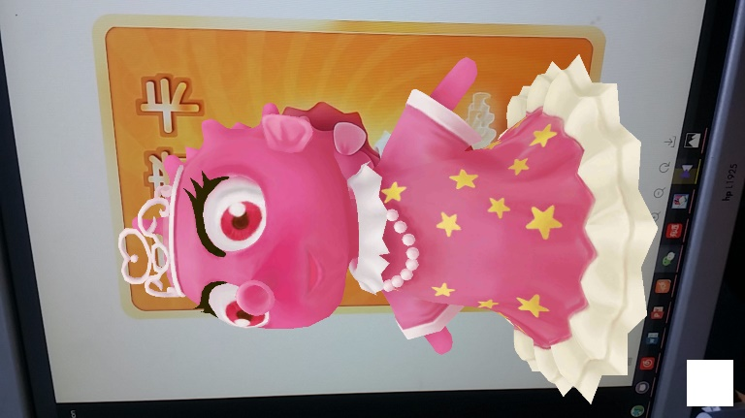 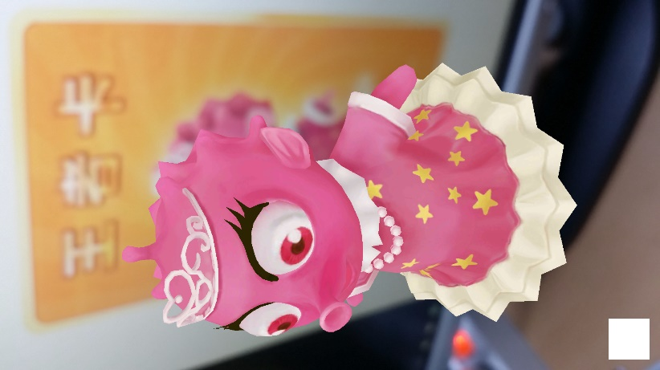 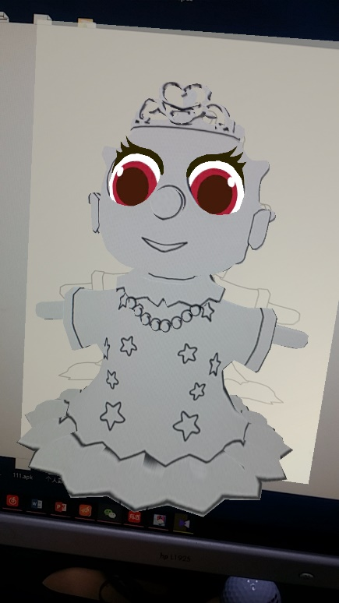

1. (b) (c)

Fig. The AR Scene(a)and (b); the AR+ Scene (c)

Three characters correspond to three recognition images, and the model of each character is not static. When stereoscopic rendering has a simple dynamic effect, when the user overlays the original image with clothespads coated with other colors, the characters Will also be three-dimensional change their clothes color. (B) use a mobile device to run the game, align the picture and display the 3d dynamic model at the top of the picture; (c) Other colors to replace the corresponding part of the identification map; (d) run the model is displayed after the change color model.

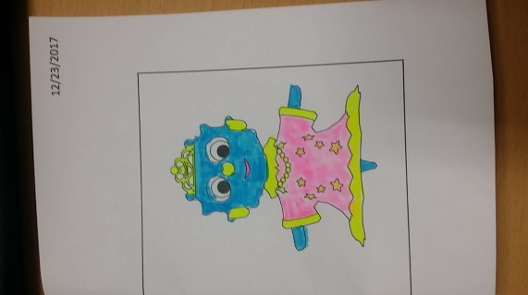 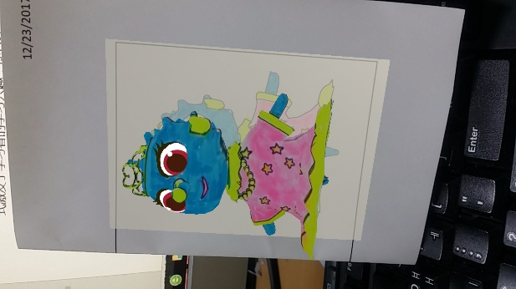 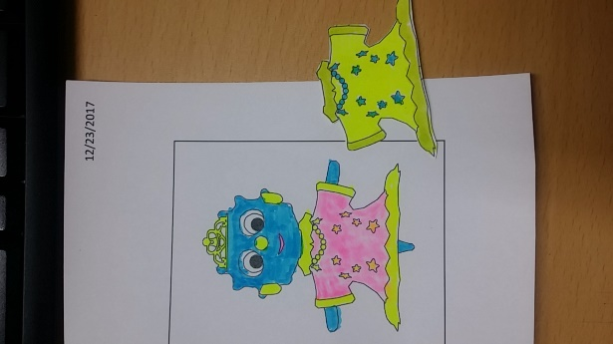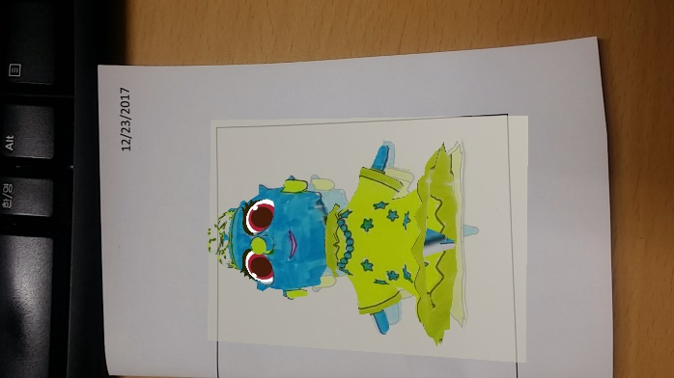

(a) (b) (c) (d)

Fig. 8. Experience on the mobile Phone

3.2 Development

The development of this procedure and the principle described above Color the Earth consistent, 此类游戏在开发的过程中有

# 4. Conculsion

The application of augmented reality technology in education provides new ideas for teaching and learning. As a representative product, AR 3D eBooks break through the limitations of paper books, provide learners with realistic visual learning materials and promote knowledge Get and absorb. "Color the Earth AR" can be used to "flatten out" the planar objects by simply and conveniently scanning the mobile terminal. The interactive form stimulates learners' interest in learning so that they can learn knowledge and know the world in the interaction with the three-dimensional concept. Of course, the AR 3D e-book is in its development stage. Both the fidelity and interaction effects of the 3D models are inadequate and need to be further improved in later research and production. With the advancement of smart classrooms and digital learning, AR 3D eBooks, as emerging learning media, will have a disruptive impact on classroom environments, teaching models and even education.

# **References**

[1]“神笔马良” – 中国的神话故事

[1] 地平线报告 [R]. 上海：SHANGHAI EDUCATION，2011．

[3] The Past, Present and Future of AR - Part 1 (AR Immersion 2010 Keynote)

<https://www.youtube.com/watch?v=TJ5DPn5l6xM>

[4] 姚远 . 增强现实应用技术研究 [D]. 杭州：浙江大学，2006.

[5]王德宇，宋述强，陈震.增强现实技术在高校创客教育中的应用[J].中国电化教育，2016，(10)：112-115.

[6] 胡智标 . 增强教学效果 拓展学习空间——增强现实技术在教育中的应用研究 [J]. 远程教育杂志，2014，(2)：106-112.

[7] Kaufmann,H.The potential of augmented reality in dynamic geometry education[C]//12th International Conference on Geometry and Graphics,Salvador,Brazil，August 6-10，2006：35-49.

[8] 蔡苏，宋倩，唐瑶 . 增强现实学习环境的架构与实践 [J]. 中国电化教育，2011，(8)：114-119.

[9] 程志，金义富 . 基于手机的增强现实及其移动学习应用 [J]. 电化教育研究，2013，(2)：66-69.

<http://www.ixueshu.com/document/bc4139a9d5c7739b318947a18e7f9386.html>

[10] Shelton B, Hedley N. Using Augmented Reality for Teaching Earth - Sun Relationships to Undergraduate Geography Students [C]. The First IEEE International Workshop, Darmstadt, Germany，September 29，2002：1-8.

[11] 韩存齐 . 无标识增强现实电子书系统研究与实现 [D]. 武汉：华中师范大学，2014.

[12] 萧冰，王茜 . 增强现实技术在儿童科普读物中的应用研究 [J]. 科技与出版，2014，(12)：108-110.